**Lab 11**

**Name :-** Aryan Dilipbhai Langhanoja

**Date :-** 22-08-2023

**Enrollment No :-** 92200133030

**CO1: To write, test, and debug simple Python programs**

**CO2: To implement Python programs with conditional, loops and functions**

**Task 1:- Matrix Dot Multiplication**

**Python Code:**

matmul1 = np.array([[1,2],[3,4]])

matmul2 = np.array([[5,6],[7,8]])

resultmul = np.dot(matmul1, matmul2)

print(resultmul)

**Output:**

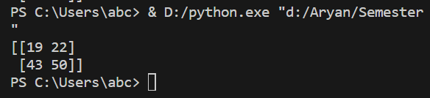

**Task 2:- Transpose Of A Matrix**

**Python Code:**

A = np.array([[1,2,3],[4,5,6],[7,18,9]])

print(np.transpose(A))

**Output:**

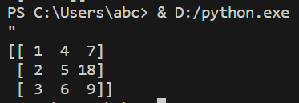

**Task 3:- Determinant Of A Matrix**

**Python Code:**

A = np.array([[1,2,3],[4,5,6],[7,18,9]])

print(np.linalg.det(A))

**Output:**

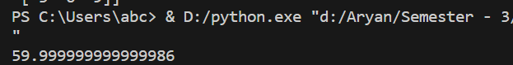

**Task 4:-** **Inverse Of A Matrix**

**Python Code:**

A = np.array([[1,2,3],[4,5,6],[7,18,9]])

print(np.linalg.inv(A))

**Output:**

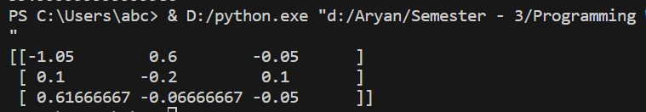

**Task 5:- Converting matrix in a single row**

**Python Code:**

A = np.array([[1,2,3],[4,5,6],[7,18,9]])

print(A.flatten())

**Output:**

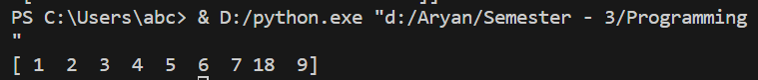

**Task 6:- Numpy Array Itteration**

**Python Code:**

Mat = np.array([[1,2,3],[4,5,6]])

for i in Mat :

print(i)

**Output :-**

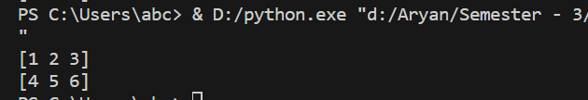

**Task 7:- Print The Element Of Matrix With only one for - loop**

**Python Code:**

arr= np.array([[[1,2],[3,4]],[[5,6],[7,8]]])

arr1 = np.array([[1,2],[5,6]])

for x in np.nditer(arr) :

print(x,end=" ")

print()

for x in np.nditer(arr1) :

print(x,end=" ")

print()

**Output:**

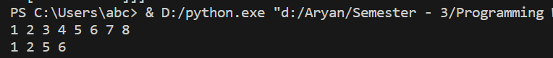

**Task 8:- Split Matrix The Matrix**

**Python Code:**

arr2 = np.array([1,2,3,4,5,6])

newarr = np.array_split(arr2,2)

print(newarr,"\n").

**Output:**



**Task 9:- Split Matrix The Matrix**

**Python Code:**

arr3 = np.array([1,2,3,4,5,4,4])

x = np.where(arr3 == 4)

print(x,"\n")

**Output:**



**Task 10:- Sorting Array**

**Python Code:**

arr5 = np.array([3,2,0,1])

print(np.sort(arr5))

arr6 = np.array(['Banana','Cheery','Apple'])

print(np.sort(arr6))

**Output:**

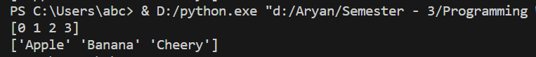

**Task 11:- Save and Load Arrays As Binary FilePython Code:**

# Creating The File

arr4 = np.array([[[11,12,13,14],[15,16,17,18]],[[18,19,20,21],[22,23,24,25]]])

file = open("arr","wb")

np.save(file, arr4)

file.close()

# Creating The File

arr4 = np.array([[[11,12,13,14],[15,16,17,18]],[[18,19,20,21],[22,23,24,25]]])

file = open("arr","wb")

np.save(file, arr4)

file.close()

**Output:**

